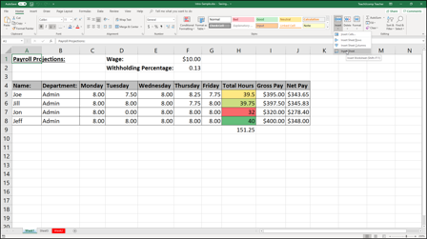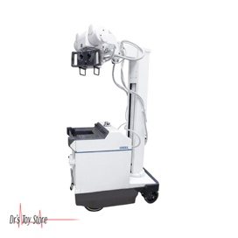

**TENZING APPLICATIONS**

**XRAY MACHINES/IMAGING MACHINES THAT CONNECT TO DICOM**

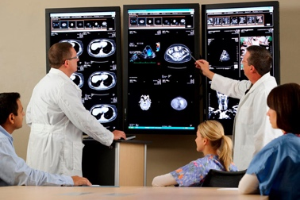

**VITAL MACHINES**

**SEPARATE EXCEL SHEETS TO LOG ERRORS, KEEP TRACK OF REFERENCE COIUNTS, AND PHARNACY PRESCRIPTION ERRORS**

**Main GTM Database and GTM Replications**